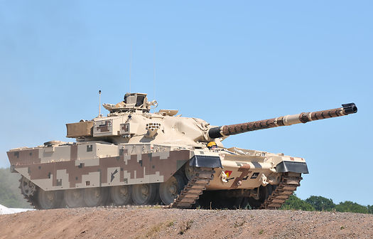­­­­­­­­­­­­­­ Issued to DS: 11 Nov 18

**KUWAITI: JOINT COMMAND AND STAFF COURSE**

**STAFF RIDE**

**DS NOTES**

Issued to DS: 11 Nov 18

**KUWAITI: JOINT COMMAND AND STAFF COURSE**

**STAFF RIDE**

**DS NOTES**

**INTRODUCTION**

1. A staff ride consists of systematic preliminary study of a selected battle or campaign, a visit to sites associated with that event, and an opportunity to integrate the lessons derived from both. It requires maximum involvement from all those attending before arrival at the site to guarantee thoughtful analysis and discussion. A staff ride thus links a historical event, systematic preliminary study, and an understanding of actual terrain to produce battle analysis in three dimensions. The staff ride is a unique technique for conveying the lessons of the past to present day leaders. In a general sense, its primary purpose is to further the professional development of leaders.

*"...battlefields can help leaders see how their decisions influence tactical outcomes, how terrain shapes engagements, and how technology, tactics, and organization interact in a battlefield setting. Those observations, when combined with curiosity and diligence, lay the groundwork for a lifetime of professional reading and will produce officers who are mentally prepared for a warfighting role."*

*(Brig Gen Harold W. Nelson).*

1. The MAJCSC Staff Ride will study the ‘Battle of the Bridges’. The battle was a successful delaying action that formed part of Kuwait’s resistance to the Iraqi Invasion at the start of the 2nd Gulf War and took place on 2 Aug 1990 between elements of Kuwait’s 35 Bde and the Iraqi 1st Hammurabi Armored Division and 2nd Al-Madinah Al-Monawara Armored Division. It was fought in the area west of Al Jahra where two bridges cross the Sixth Ring Road at the junction with Highway 70. The Battle is sometimes referred to as the ''Battle of the Jal Al Atraf’’, Jal Al Atraf being the name of a nearby ridge.
2. The author wishes to apologize to all those Kuwaiti Officers and men who contributed to this successful engagement but have not been mentioned. This is purely as a result of a lack of space in this document or a lack of source information and in no way seeks to lessen their contribution.

List of Appendixes:

1 Battle of the Bridges Staff Ride Overview – Map 1

2 Why Did Iraq Invade Kuwait – Historical Context – Stand 1

3 Road to War – Stand 2

4 Iraqi SF and Air Assault Capabilities – Stand 3

5 Iraqi decapitation operations Dasman Palace – Stand 4

6 Iraqi Land Force Equipment and Capabilities – Stand 5

7 Iraqi Ground Invasion – Stand 6

8 Iraqi Invasion Plan – Map 2

9 Kuwaiti Recall and Deployment – Stand 7

10 35 Bde Occupies its Battle Positions – Map 3

11 35 Bde Equipment and Capabilities – Stand 8

12 Role of Artillery in the battle – Stand 9

13 1st Artillery Engagement – Map 4

14 2nd Artillery Engagement – Map 5

15 Artillery Engaged by BMPs – Map 6

16 Battle of the Bridges – Phase 1: 1st Hammurabi Armored Div - Stand 10

17 Engaging the Hammrabi Div on 6th Ring Road – Map 7

18 Battle of the Bridges – Phase 2: 2nd Al-Medinah Al-Munawera Armd Div – Stand 11

19 The Medina Div Approaches from the West – Map 8

20 Battle of the Bridges - Phase 3: Withdrawal - Stand 12

21 35 Bde Withdrawal – Map 9

Appendix 1

**MAP 1 – BATTLE OF THE BRIDGES STAFF RIDE – OVERVIEW**

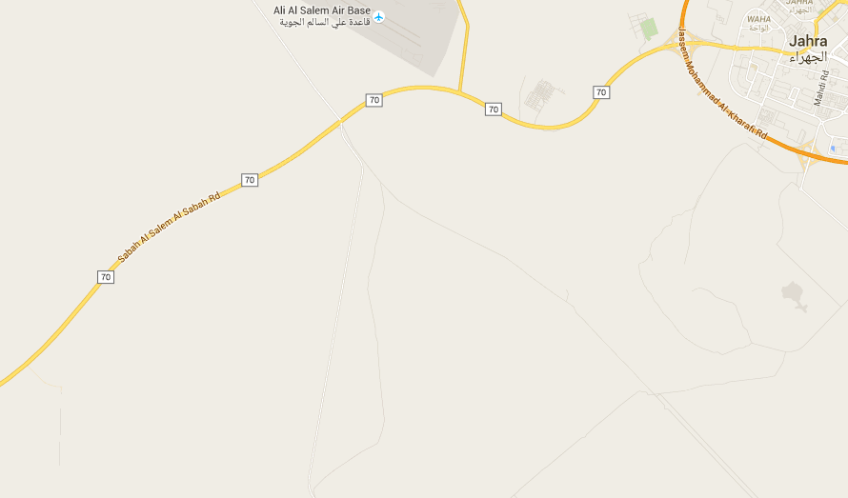

35 Bde

Battle Site

Artillery Location

Appendix 2

**WHY DID IRAQ INVADE KUWAIT? – HISTORICAL CONTEXT – STAND 1**

Overview

The Invasion of Kuwait resulted in the seven-month-long Iraqi occupation of Kuwait, and subsequently led to direct military intervention by US-led forces in the [Gulf War](https://en.wikipedia.org/wiki/Gulf_War). The invasion started on 2 August 1990, and within two days, the [Kuwait Armed Forces](https://en.wikipedia.org/wiki/Military_of_Kuwait) were either overrun or fell back to neighboring [Saudi Arabia](https://en.wikipedia.org/wiki/Saudi_Arabia) and [Bahrain](https://en.wikipedia.org/wiki/Bahrain). Kuwait was annexed, and [Saddam Hussein](https://en.wikipedia.org/wiki/Saddam_Hussein) announced that it was now the 19th Province of Iraq. The attack was conducted by eight Republican Guard divisions (two armored, two mechanized, three motorised infantry and one Special Forces). The main thrust was conducted from the north down the main Iraq-Kuwait road with a supporting attack from the west, .Special Forces deployed by helicopter and boats carried out an attack on Kuwait city to try and kill or capture the royal family.

Historical Reasons for the War

International relations between Iraq and Kuwait have historically been turbulent. This dates back to late in the 19th Century when Kuwait

had been claimed by the Ottoman District of Basra however its borders were never clearly defined or mutually agreed. This problem was addressed in the Anglo-Ottoman Convention of 1913, where Kuwait was established as an autonomous district of the Ottoman Empire and a de facto protectorate of Great Britain. The convention ruled that Sheikh Mubarak Al Sabah had authority over an area extending out to a radius of 80 km, from the capital. In addition he was granted the authority to collect tribute and taxes from the natives out to a further 100km. However, after signing the Anglo-Ottoman Convention of 1913, the United Kingdom split Kuwait from the Ottoman territories into a separate sheikhdom.

In the early 1920s Mubarak Al Sabah claimed the outer limit (180Km) of the Anglo-Ottoman Convention as Kuwaiti territory and the British Government subsequently recognized this line as the border between Iraq and Kuwait in the Uqair Protocol of 1922. This decision limited Iraq's access to the Arabian Gulf to 58 km of mostly marshy and swampy coastline. As this would make it difficult for Iraq to become a naval power (the territory did not include any deep-water harbours), the Iraqi King did not, initially, agree to the plan. However, as his country was under British mandate, he was eventually encouraged to do so and Iraq and Kuwait formally ratified the border in August 1923. The border was internationally recognized in 1932.

This state of affairs continued until the late 1950s when Abdul Karim Qasim seized power in Iraq and quickly started to make threatening noises towards Kuwait. It therefore came as no surprise when on June 28th 1961 (just over a week after Kuwait had been granted independence) Qasim started to mass Iraqi forces on the Kuwaiti border. However, he quickly backed down when the UK deployed forces to Kuwait as part of Operation Vantage and the situated cooled further after Qasim was assassinated in 1963, although the Iraqis occupied El-Samtah near the Kuwait border in 1973 and only withdrew under Saudi pressure.

Saddam used this historical dispute as part of his justification for the war when he argued that he was merely annexing territory that rightly belonged to Iraq and he was just reclaiming an area carved off as a result of British imperialism. In much the same way as the Argentinians used the their claim on the Falkland Islands to distract their population from internal troubles Saddam did the same with the Iraqis The Iraqi government also spuriously argued that the Kuwaiti Amir was a highly unpopular figure among the Kuwaiti populace. By overthrowing the Amir, Iraq claimed that it would grant Kuwaitis greater economic and political freedom.

Appendix 3

**ROAD TO WAR – STAND 2**

Debt & Alleged Economic Warfare And Slant Drilling

When the Iran–Iraq War broke out, Kuwait initially stayed neutral and also tried mediating between Iran and Iraq. However, in 1982,

Khomeini openly attempted exporting the Iranian Revolution to Kuwait. As a result, Kuwait started to support to Iraq in the form of

financial backing and loaned Iraq somewhere between 14 and 60 billion dollars. After the war ended, the friendly relations between the

two neighboring Arab countries turned sour when it became apparent that Iraq was in no position to pay off its debts. Moreover, Iraq

argued that it had fought the war on behalf of Kuwait and as such Iraq considered the money at best as payment for its efforts or at worst a gift from a grateful Kuwait.

One of the reasons Iraq was unable to pay its debt was that it was unable to generate sufficient revenue from its oil production. By seizing Kuwait and gaining control of its oil fields Iraq would be in possession of 20% of the world’s oil reserves and so should be able to quickly solve its financial crisis. In order to try and justify this course of action and gain support in the International community Iraq started a campaign of propaganda and misinformation where it accused Kuwait of over producing its oil quota and so keeping prices down. Former Iraqi Foreign Minister Tariq Aziz claimed that, "every $1 drop in the price of a barrel of oil caused a $1 billion drop in Iraq's annual revenues triggering an acute financial crisis in Baghdad’ and he further went on to claim that ‘between 1985 and 1989, Iraq lost $14 billion a year due to Kuwait's oil price strategy’. He further stated that Kuwait’s ‘’refusal to agree to Iraqi demands to decrease its oil production was tantamount to an act of aggression’’. A lack of consensus among OPEC members undermined Iraq's efforts to end the oil glut and consequently prevented the recovery of its war-crippled economy. The increasingly tense relations between Iraq and Kuwait were further aggravated when Iraq, without any proof or legal justification, accused Kuwait of using "advanced drilling techniques" or ‘slant drilling’ to exploit oil from its share of the Rumaila field and claimed that ‘$2.4 billion worth of Iraqi oil was "stolen" by Kuwait and demanded compensation.

Iraqi–American Relations

A further reason behind the Iraqi invasion was Saddam’s belief that the USA would not interfere. He was given this impression by the US

Ambassador to Iraq, a Miss April Glaspie, when she declared that Washington “inspired by the friendship and not by confrontation, does

not have an opinion” on the disagreement between Kuwait and Iraq, stating "we have no opinion on Arab–Arab conflicts".

She also let Saddam Hussein know that the United States did not intend "to start an economic war against Iraq". These statements may

have caused Saddam to believe he had received a diplomatic green light from the United States to invade Kuwait.

Iraqi Military Power

By the eve of the Invasion of Kuwait the Iraqi Army was estimated to number 1,000,000 men. It had 47 infantry divisions, 9 Armored and

Mech Divs and 12 Republican Guard Divs, Many of which had seen action in the Iran-Iraq war. Given that Kuwait could barely muster the equivalent of 1 Division, Iraq thought its victory was a forgone conclusion.

Appendix 4

**IRAQI SF AND AIR ASSAULT CAPABILITIES – STAND 3**

The Iraqis had one Special Forces Division, the 8th As Saiqa Special Forces Division which contained a marine brigade, a parachute

brigade, and a Special Forces brigade. Just prior to the invasion it was moved to a forward position and based South-West of Al-Basrah.

The Commandos deployed by helicopters and boats to attack Kuwait City. To support the Air Assault element of the attack, the Iraqi

Army deployed a Squadron of Mi-25 Hind helicopter gunships, a number of Bo 105 light helicopters, several units of Mi-8 and Mi-17

transport helicopters and a Squadron of Bell 412 helicopters. Indeed, sources suggest that there were as many as 50 transport

helicopters used in the first wave of the Air Assault, suggesting an initial Air Assault force in the order of 1000 commandos. The Iraqi Air

Force also had a squadron of Sukhoi Su-22 Fitter fighter bombers, a squadron of Sukhoi Su-25 Frogfoot ground attack aircraft, a

squadron of Mirage F1 fighters and 2 squadrons of Mig 23 Flogger fighter bombers tasked to establish air superiority over Kuwait to

support the invasion.

The Mi-25 Hind is the export version of the Soviet Mi-24 helicopter, a large heavily armed helicopter gunship affectionately referred to by

Soviet pilots as the ‘flying tank’, and probably best remembered from the Soviet occupation of Afghanistan where it was used extensively

to bomb the Mujahedeen. Used here by the Iraqis in the escort role, the Hind is also capable of carrying up to 8 passengers 280 miles at

speeds of up to 180 kts.

Also used in the escort role on 2nd August 1990 was the Messerschmitt-Bölkow-Blohm or Bo 105, a light twin engine multi-purpose

helicopter which can carry limited ground attack weapons on pylons fitted to the sides of the fuselage. Capable of flying at speeds up to

130 kts it has a range of 350 miles and was the first production helicopter capable of performing aerobatic maneuvers such as a loop

due to its hinge-less rotor system.

To lift the Commandos, the Iraqis used the Mi-8, Mi-17 and Bell 412 helicopters. Of Soviet origin and first flown in 1961, the Mi-8 and the

more powerfully engined Mi-17 Hip helicopters remain highly successful utility transport helicopters operated by over 50 nations around

the world, capable of carrying 24 passengers 280 miles at speeds of up to 140 kts. While smaller than the Hip, the Bell 412 is a 2

engined derivative of another highly successful helicopter design, the Huey UH-1 helicopter best known for its crucial role in the Vietnam

War. Capable of carrying 13 passengers 600 miles at speeds of up to 140 kts, the Bell 412 was also a highly capable platform. Appendix 5

**IRAQI DECAPITATION OPERATIONS DASMAN PALACE – STAND 4**

In the early hours of the morning on 2 Aug 1990, more than 100,000 Iraqi troops crossed the border into Kuwait. I will leave discussion of the finer nuances of the Republican Guard advance across the border to my Land colleagues – what I want to focus on is the Commando Air Assault on the Dasman Palace – an attempt by the Iraqis to decapitate Kuwaiti leadership by capturing or killing the Amir, Sheikh Jaber Al-Ahmad Al Jaber, and members of his immediate family.

Based South-West of Al-Basrah, the Commandos deployed by helicopters and boats to attack Kuwait City. To support the Air Assault element of the attack, the Kuwaiti Army deployed Squadron of Mi-25 Hind helicopter gunships, a number of Bo 105 light helicopters, several units of Mi-8 and Mi-17 transport helicopters and a Squadron of Bell 412 helicopters. Indeed, sources suggest that there were as many as 50 transport helicopters used in the first wave of the Air Assault, suggesting an initial Air Assault force in the order of 1000 commandos. The Iraqi Air Force also had a squadron of Sukhoi Su-22 Fitter fighter bombers, a squadron of Sukhoi Su-25 Frogfoot ground attack aircraft, a squadron of Mirage F1 fighters and 2 squadrons of Mig-23 Flogger fighter bombers tasked to establish air superiority over Kuwait to support the invasion.

Iraqi infiltrators and the Air Assault Commandos attacked the Dasman Palace at about 0500 on the morning of the 2nd, to be met by fierce resistance from the Amiri Guard who were able to repel the initial assault. Small units from the Iraqi Forces managed to take positions on the roofs of some of the buildings surrounding the entrance to the Dasman Palace, from where they were able to target the defending forces, but it was to be 2 hours before they were able to force the gates. However, Saladin Armored Cars from the Amiri Brigade arrived in the nick of time and succeeded in breaking the Iraqi blockade around the Palace. With the situation looking desperate, a National Guard Mechanised Infantry Squad was also dispatched to assist the Amiri Guard and by 0900 the combined Amiri Guard and National Guard forces had managed to defeat the initial Air Assault forces. As the morning passed, 2 further mechanical infantry platoons from the National Guard arrived to help defend the Palace Main Gate.

Referring to the assault on the Dasman Palace, Carlyle Murphy from the Washington Post reported that: ‘machine-gun and bazooka fire as well as small artillery could be heard throughout that time, indicating that the Kuwaiti forces put up considerable resistance.’ However, despite some brave resistance, eventually numbers would tell, and by 1200 hours, an Iraqi Force the size of a mechanical infantry division faced a combined Kuwaiti Amiri and National Guard force of no more than battalion strength. To avoid a massacre, the Kuwaitis sent out a team to negotiate terms for surrender, but when the negotiating team was taken prisoner, the other Kuwaiti elements within the Palace withdrew leaving the Palace to fall to Iraqi forces – Kuwaiti casualties: 2 killed, 15 wounded and 5 taken Prisoner of War.

Iraqi helicopter losses during the air assault are impossible to verify as much of the transit took place at low level over the Arabian Gulf and the Iraqis themselves have never published any figures – the Kuwaiti armed forces claim as many as 23 kills against Iraqi helicopters, including 13 shot down by Kuwaiti Air Force Mirage F1s and 3 by A4 Skyhawks. Several helicopters also hit high tension cables once over land in Kuwait and the loss of these aircraft undoubtedly added to some initial Iraqi chaos and confusion which helped the defenders prevent the initial capture of the Palace and provided more time for members of the Royal Family to be evacuated.

From an Iraqi perspective, the air assault didn’t achieve its aim as the Amir and many of his family were successfully evacuated and so able to avoid capture. The most notable casualty from a Kuwaiti perspective, the Amir’s younger half-brother Sheikh Fahad Al-Ahmed Al-Jaber Al-Sabah who was shot and killed by a sniper – Sandhurst trained, he had stayed behind to lead the defense of the Palace.

Appendix 6

**IRAQI LAND FORCE EQUIPMENT AND CAPABILITIES – STAND 5**

By the eve of the Invasion of Kuwait, the Iraqi Army was estimated to number 1,000,000 men. The force comprised 47 Inf Divs plus 9

Armd and Mech Divs, grouped in 7 corps. This gave a total of about 56 army divs. The majority of Iraqi armored forces still used old

Chinese Type 59s and Type 69s, Soviet-made T-55s from the 1950s and 1960s, and some T-72s from the 1970s. These machines were

not equipped with up-to-date equipment, such as thermal sights or laser rangefinders, and their effectiveness in modern combat was very

limited. However, the Invasion was spearheaded by 5 of the 12 Iraqi Republican Guard Divs with more modern equipment.

The 2 Republican Guard divs heading to Kuwait City were 1ST Hammurabi Armd Div consisting of 8TH and 17TH Armd Bdes and 15th Mech Inf Bde, and 6th Nebukhath Nassar Motorised Inf Div consisting of 19th and 22nd Motorised Inf Bdes and one Armd Bde. The 2 Republican Guard divisions on the southern axis were the 2nd Al Madinah Al Munawara Armd Div consisting of 2nd and 10th Armd Bdes and 14th Mech Bde, and the 3rd Tawakalna Ala Allah Mech Inf Div consisting of 2 Mechanised Bdes and one Armd Bde. The Divs also included artillery, with an engineer, commando, air defense and reconnaissance battalion plus logistics elements. Each maneuver brigade consisted of 3 tank battalions and 1 mechanized, or 3 mechanized and 1 tank. The Bde also had a Reconnaissance platoon and Mortar Battery.

These Divs were equipped with T-72M tanks and BMP-2 Armored Personnel Carriers. Most of the Iraqi T-72M were export models from

the USSR. The export "Monkey model" version was similar to the standard Russian T-72A but lacked composite armor and had a

down-graded weapon systems, with no fire-control systems. Some of the T-72M had been assembled in Iraq using spare parts and these

were called the Lions of Babylon. The T-72 had a 125mm main gun effective up to between 1800 and 2000m and a 7.62mm mounted

machine gun. The tank has a range of up to 460km which could be extended to 700km with fuel drums attached. It has a maximum

speed of 60km/hr.

The BMP-2 was also Soviet equipment with a crew of 3 (commander, gunner and driver) and 7 infantry soldiers. It was armed with a

30mm automatic cannon with an effective range of up to 1,500m against armor, 4,000m against ground targets. However, reloading the BMP-2's 30mm cannon could be somewhat problematic, and could take up to 2 hours. The gun has a selectable rate of fire, either slow at 200 to 300 rounds per minute or fast at 550 rounds per minute. The original stabilization provided reasonable accuracy

up to a speed of about 35 km/hr. The cannon was normally only used on the slow rate of fire, otherwise fumes from the weapon would

build up in the turret faster than the extractor fan could remove them. It was also capable of carrying an ATGM weapons system of either

the Spigot with a maximum range of 2000m or the Konkurs with a maximum range of 4000m. The vehicle had a range of up to 600km

with maximum on road of 65km/hr and off road of 45km/hr.

Appendix 7

**IRAQI GROUND INVASION – STAND 6**

**Plan**

The Iraqi plan for the operation against Kuwait was actually based on the combination of old British plans from the 1950s, "updated" on

the basis of the lessons from the last 18 months of the war against Iran, with various new elements - with one exception: no chemical

warheads were to be used, even if the use of chemical weapons was a standard part of Iraqi tactical doctrine since 1987.

The Iraqis attempted to make the least use of force possible: instead of starting their invasion by powerful air strikes and artillery

bombardments their military could mount, they planned to deploy commando units into Kuwait City, with the task of capturing the royal

family. Simultaneously, 4 Iraqi Republican Guard Divs would drive deep into Kuwait: 2 were to occupy the capital, while another 2 would

execute an enveloping maneuver and cut off communications between Kuwait City and the Saudi border. Therefore, after the first

counter-air strike against the Kuwaiti airfields, air and artillery strikes would be undertaken only to keep the KAF on the ground.

The 4 Republican Guard Divs used for the invasion were:

- 1st Hammurabi Armd Div (with 8th and 17th Armd Bdes, and 15th Mech Inf Bde, equipped with a total of some 350 T-72

MBTs and 100 BMP-2 APCs) and 6th Nebukhath Nassar Motorized Inf Div (with 19th and 22nd Motorized Inf Bdes, and one

armored brigade).

-- These were deployed north of Kuwait, along the Highway 6, connecting Basrah and Kuwait City; they were to strike

directly on Kuwaiti capital.

- 2nd al-Medinah al-Munawera Armd Div (with 2nd and 10th Armd Bdes, and 14th Mech Bde, equipped with T-72 MBTs and

BMP-2 APCs) and 3rd Tawalkalna al-Allah Mech Inf Div (with 2 mechanized and 1 armored brigade).

-- These were deployed north-west of Kuwait; they were to attack from north-west, across the Wadi al-Batin, charge

towards the south and then east, thus cutting off all land connections between Kuwait and Saudi Arabia.

- The Iraqis also deployed a division-sized force of Republican Guard Special Forces, airborne troops and Marines from

south-west of Al-Basrah in an attempt to seize or kill the Kuwaiti leadership.

**Execution**

**2 August 1990: Iraqi Invasion**

The Iraqi attack had been launched at 0100hrs on 2 Aug 1990, with the T-72s and mechanized infantry of the al-Madinah al-Munawara

Div rolling over the border south of Safwan and along the Highway 6 towards Kuwait City. There was no initial opposition. The Iraqis

swiftly bypassed the base of the 6th Kuwaiti Mech Bde, and rushed towards south, reaching the outskirts of Kuwait City already by 0500

hrs. Simultaneously, the Al-Madinah al-Munawara Armored Div entered the Rumailah oilfields and raced towards the south, bypassing

the base of the Kuwaiti 35th Mech Brigade in the process.

At dawn, both sides brought their air forces into action, and it was around this time – shortly after 0500 hrs – that the Kuwaiti air defense

units were activated. Shortly before the first wave of IrAF fighter-bombers arrived, two KAF A-4KUs were scrambled from the Ahmed al-

Jaber AB. They attacked the front column of the Al-Madinah al-Munawara Armd Div, making two strafing passes each.

The Al-Madinah al-Munawara Armd Div entered Kuwait City by 0530 hrs, its T-72s and BMP-2s racing down the main streets, only to

become bogged down in a series of traffic jams. The failure of this unit to drive through the Kuwaiti capital, and the slow pace at which

the Hammurabi Armd Div followed, permitted the bulk of the Kuwaiti 15th Brigade, located south of Kuwait City, to escape to Saudi

Arabia with most of its assets, and also permitted the KAF units at Ahmed al-Jaber AB to prepare additional aircraft for evacuation. At

Bayan Palace, the Amiri Guard – supported by several Saladin armored cars – fought delaying action, but was soon overwhelmed.

By the noon, the Iraqis were in full control of Kuwait City and Kuwait International Airport, except such key locations like the Bayan

Palace. The assault on the last complex was launched at 1300 hrs with artillery support. The Amiri Guard had already fought back the

whole morning, but was now silenced.

**3rd and 4th of August**

With most of Kuwait swiftly overrun by the Iraqi military, the second day saw only limited action. During the night, the Iraqis finally put the

Kuwaiti TV out of operation, while several KAF Super Pumas were used for transporting ammunition to isolated pockets of Kuwaiti Land

Forces still resisting the Iraqi onslaught.

On the ground, scattered Kuwaiti units were still fighting delaying actions along chock points in the south, until being overrun or running

out of ammunition. Those that could then retreated into Saudi Arabia.

Despite mishaps, the overall success of the Iraqi invasion was never in question: it had to succeed due to simple numbers. However,

there were two crucial mistakes, the first was the failure to capture the Amir of Kuwait, or at least the other higher members of the Royal

Family, and the other was their inability to sack the rest of the KAF on the first day of the war.

It seems that the Iraqis, especially the Republican Guard, had not taken the Kuwaitis particularly seriously: they repeatedly showed the

lack of discipline of a well-trained and combat-hardened army. Much too often they were involved in scavenging food from the locals and

stealing bedding items for their hastily-constructed fighting positions. This allowed thousands of Kuwaitis and foreigners to escape over

to Saudi Arabia before the border was finally sealed on 11 August.

Finally Iraq formally announced it had annexed Kuwait making it the 19th province, installing Saddam Hussein as a new provincial

governor and describing its operation as “liberation” of the county from the Amir of Kuwait.

Appendix 8

**IRAQI INVASION PLAN – MAP 2**

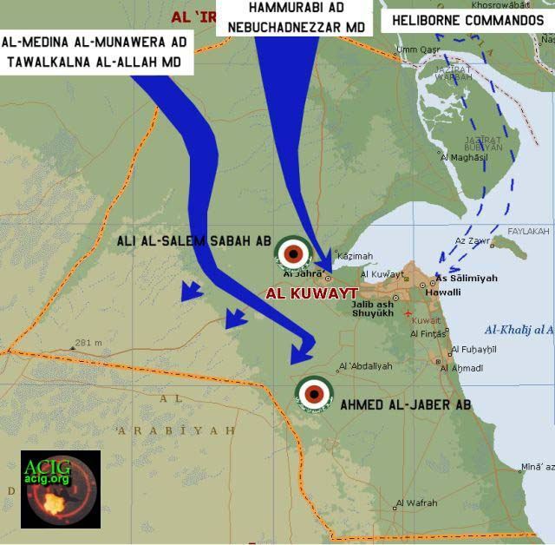

Appendix 9

**KUWAITI RECALL AND DEPLOYMENT – STAND 7**

When Iraq invaded Kuwait the Kuwaitis were caught unprepared. Despite the diplomatic tension and the Iraqi build-up on the border, no

central orders were issued to the Kuwaiti armed forces and most were not on alert. Many of the personnel were on leave as 2 Aug was

both the Islamic New Year and one of the hottest days of the year. There was also a great deal of confusion and speculation, with many

believing that this would be just a repeat of 1973 when Iraqi forces limited themselves to occupying some of the border areas and later

withdrew as a result of Saudi diplomatic pressure.

However, one formation that did deploy was elements of 35 Bde, and it’s their story we will look at.

At 2200 hrs on 1 Aug, the 35th Bde Operations Officer learned of the impending invasion and placed the Brigade on alert. Those officers

and men who could be contacted were alerted by telephone and quickly assembled. Because of the confusion many personnel were late

or not available and new crews had to be assembled on the spot using the available personnel. Capt Nasser, XO of 7th Battalion, began

combing through personnel files of soldiers on base. If they had had any armor training, no matter how long ago, they were assigned to

composite crews, so clerks who had done some tank training years before could suddenly find themselves as part of a crew.

The first indication of the Iraqi ground advance was from a radar-equipped balloon that detected an Iraqi armor column moving south

and crossing the border shortly after 0000 local time on 2 Aug. At 0030 hrs the Bde received information the Iraqis occupied Al Ratqa; by

0100, they’d occupied all of the frontier boundary centres in the north.

From the Bde Commander's perspective, things were very confused. There were many tasks to be done and the situation was unclear. A

significant number of personnel were still deployed executing routine peacetime guard missions and could not be recalled in time to fight

with the Bde. However, the remaining officers and men worked side by side without any regard for rank to prepare to deploy.

Unfortunately, they were unable, despite their haste, to load everything necessary in a limited time or to bore-site their weapons. Critically

they did not load enough water or a full load of ammunition. Additionally, they lacked the man power to man all their equipment. As a

result the Brigade was only able to field the following:

- 36 Chieftain Tanks (reduced to 35 when one broke down enroute) in 3 companies from the 7th Bn and 1 from the 8th

- 1 Company of Armored Personnel Carriers made up of five BMP-2s plus several M113s

- An Anti-Tank Coy

- A single Artillery battery of 7 guns

Col Salem departed the camp at 0430 with the Anti-Tank Coy. The Anti-Tank Coy initially deployed in 2 sections, one section

went to the Al Salem airbase to provide security, and the second to secure the intersection of the 6th Ring Road and the Al Salmi Road.

During their move east along the Al Salmi Road, they witnessed an Iraqi air raid on the Al Salem airbase.

The remaining forces of the brigade moved out of the camp as they completed assembly at 0600 to a position near the junction of 70 and

6th where they dispersed to deny the Iraqis a good target.

The deployment was completed when, at about 0645, Lt Col Ahmad Al Wazzan sent a Reconnaissance vehicle forward to the vicinity of

the police station on the Mutla Ridge to investigate activity on the Al Abdaly Road.

Appendix 10



Appendix 11

**35 BDE EQUIPMENT AND CAPABILITIES – STAND 8**

The entire Kuwaiti Land Forces only consisted of about 16,000 men, most of whom were either in their bases or away on leave, and a

significant number of tanks and other vehicles had been placed in storage. 35 Bde was no exception to this and although on paper 35

Bde comprised 2 Tank Bns (the 7th and 8th), 1 Mech Inf Bn (the 57th), an anti-tank company, and the 51st Artillery Bn, all they could field

were 3 Companies with 26 tanks in total from the 7th Tank Bn, and a further 10 from the 8th Tank Bn. Its Inf Bn, the 57th, could only field

one understrength company with 5 BMP-2s & several M113s, and the Artillery Bn only 7 of its 18 M109A2s. In addition it also had an

understrength Anti-Tank Coy equipped with M901 ITVs. Turning to the equipment itself:

The Chieftain Tank

The Chieftain was a British built main battle tank designed in the 1960s. In its time it was seen as the “most formidable main battle tank in

the world”. It was faster than the Centurion, able to maintain its speed longer than the Leopard 1 and out-gunned all its contemporaries.

It had a crew of 4 and weighed 55 tons. Its front armor was 195mm thick and it was armed with a 120 mm rifled tank gun with a laser

range finder that could fire 10 rounds per minute for the first minute and 6 thereafter. In addition it had two 7.62mm machine guns, one

coaxial and the other cupola-mounted.

The Kuwaiti version of the Chieftain tank was the MK 5/2, although aging this was still a formidable fighting platform. As well as a laser

rangefinder it was equipped with a ballistic computer, infrared night sight, and target designating capability. However, on the day of the

battle the accuracy of the gun was affected by the fact that the Kuwaitis had not been able to bore site their weapons. The main

weakness of the Chieftain lay in its engine. The tank was underpowered and prone to breakdown. Most Kuwaitis describe it as "Good

gun, bad engine". The Chieftain was due to be replaced by the M84 in the Kuwaiti Land Forces.

BMP-2

The BMP-2 was a Soviet built infantry fighting vehicle dating back to the 1970s. It was fitted with a 2-man turret mounting a fully stabilized dual-fed 30mm cannon capable of engaging armored targets at a range of 1500m, ground targets at a range of 4000m and

helicopters at a range of up to 2500m. There was also a coaxial 7.62mm machine gun. It had a cramped interior that could accommodate up to 7 soldiers with the vehicle commander in the turret.

M-113

The M113 was a US-built armored personnel carrier introduced in the 1960s. Its main armament was a 12.7mm machine gun mounted

over commander's hatch. It could carry 11 troops.

M901 ATVs

The M901 ITV (Improved TOW Vehicle) was a Tank Destroyer utilizing the BGM-71 TOW Anti-Tank missile and based on the M-113.

Nicknamed the "Hammerhead", the launcher slews 360 degrees in 10 seconds, elevates to +34 degrees, and depresses to -30 degrees.

Missiles can only be fired when the vehicle is stationary. A total of 12 TOW missiles are carried.

M109A2s

35 Bde’s artillery consisted of 7 M109A2s. The 155-mm is a self-propelled medium howitzer. It has a cruising range of 350km at speeds

up to 56km/hr. The M109 series weighs 25 tons. The M109A2 fires a 44kg projectile up to 23 800m and it carries 36 of these. The

system is capable of both direct (line of sight) and indirect (out of the line of sight) firing.

Appendix

**ROLE OF ARTILLERY IN THE BATTLE – STAND 9**

*NB. There is a degree of confusion over the location of the artillery during the battle with some eyewitnesses suggesting that it located*

*further north than shown on the map. We will use the position shown on the map; however, the basic lessons remain the same*

*regardless of the position).*

Overview

Due to manning, serviceability and supply issues, 35 Bde’s Artillery bn, the 51st, could only prepare 7 of their 18 guns. Furthermore, the

guns were not loaded with a complete mix of ammunition. This initially limited the guns options when they executed fire missions.

Also it is unclear what elements of the rest of the artillery system were available. A gun battery is much more than just the guns, it also

requires a means of acquiring, locating and tracking a target precisely enough to have an effect with the first (or at least the second or

third) round fired. This may have been as simple as an observer peering through a pair of old binoculars and reporting the fall of shot

with a radio. When you consider that this observer is likely to be subject to random gunfire, sun, dust, smoke, and maneuvering to avoid

being hit plus the fact that the targets are also maneuvering and the opposing forces were only separated by a distance of 1000 - 1500m

then you start to see some of the complexities that were involved.

A further difficulty that caused problems throughout the engagement was problems with communication between all the elements of 35

Bde, as in 1991 the analogue radio networks used by the Kuwaitis were notoriously poor. But at least they were better off than the Iraqis

many of which had no radios and relied on laying field telephone systems for communications. This is perhaps why the Iraqis only

managed one counter-battery fire mission and this was quickly avoided by the Kuwaiti’s by the simple expedient of moving. Also

command and control was subtly different on both sides, the Kuwaitis adopted the NATO system with the observer with the supported

troops directly ordering artillery support, which he then directs at the target. This allows any observer with the troops in contact a degree

of flexibility and freedom to apply fire wherever and whenever he wants. This is why in this case the Commander of the 51st Artillery was

to be found forward with 7 Bn, and his deputy or XO was commanding the guns to the rear. The Iraqis on the other hand had a much

more rigid system of pre-planned fires and so were far less able to support their maneuver units in what was essentially a meeting

engagement.

Quite apart from problems with command and control, and a limited number of guns, as already mentioned the Kuwaiti artillery was

adversely affected by its lack of ammunition, each vehicle only carrying 36 rounds of which 6 were smoke. This entire load could be

fired in minutes. Just to give you some indication of what would normally be required, the UK planning figure for a battalion of 18 guns is

just under 5000 rounds for one hour firing for effect. Compare this to the fact that the 51st only had a little more than the 210 rounds

initially available to them. Fortunately, due to the close proximity to 35 Bde HQ, a number of resupply runs were carried out during the

fighting which enabled the guns to keep firing. However, this of course stopped when the second Iraqi Div approached from the West

cutting the Artillery off from their supplies, and was one of the factors the Bde Commander had to take into account and contributed to the decision to withdraw towards the Saudi border.

The Engagement

During the first engagement the Kuwaitis quickly brought effective Artillery fires on to the Hammurabi Div near the bridges, causing

casualties and confusion among the Iraqis. Lt Col Fahad Al Hashash, the 51st Artillery Bn Commander and Capt Ghasan Suliman, the 2nd Battery Commander were forward acting as observers. The guns were manned by composite crews of all ranks because the Bn had not

fully assembled. Maj Nabil Essa, the Bn XO, commanded the guns. These fires caused the Iraqis to continue to withdraw to the west

over the Mutla Ridge. Unfortunately, the Iraqis established their own artillery in firing positions just north of the Al Salmi Road on the west

end of the Mutla Ridge. They placed accurate fires on the Kuwaiti positions. Several rounds hit near the Bde Command Group, seriously

wounding the Artillery Bn Commander, Lt Col Fahad, so that Maj Nabil, the Bn XO, had to take command of the battalion.

Fire support was also provided when the Al Madina Div had their meeting engagement with 35 Bde. This was particularly effective when

the lead elements of the Al Madina pulled back to the weigh station to regroup, and presented an attractive target to 51 Bn’s guns, and so were taken under highly effective fire causing large numbers of casualties and forcing the Div to retreat much further to the west.

Later on the Iraqis (probably the Al Madina?) threatened to attack the artillery from the north with a company of BMPs and fired several

rounds of 30mm in their direction. Although several rounds hit the position, the Iraqis were firing armor-piercing instead of high

explosive ammunition and did not get a direct hit or cause any casualties. The gunners prepared to engage them with direct fire and this

was enough to convince the Iraqis to break off their attack and withdraw. The 51st then moved south and east to new firing positions that

were farther away from the Iraqis and less exposed.

Towards the end of the engagement when trying to cover the break clean and withdrawal of the rest of the Bde, the 51st Artillery Bn set

up 10km to the south and prepared to fire. They were delayed in firing while observers moved into position and then again by

communications difficulties. Fortunately, covering fire was not required for the withdrawal and, following the rest of the Brigade, the 51st

Artillery Bn was able to move south towards the Saudi border.

Equipment

All the Artillery support came in the form of a handful of US made M109A1B 155mm self-propelled gun-howitzers. Weighing 25 tons

and 9m long it has a basic crew of 6, but this is usually doubled on operations to allow for the extra ammunition handling needed. The

Kuwaitis had nowhere near this number of men available in 1991, putting them at a distinct disadvantage. The important thing to note

that these guns were not armored fighting vehicles or tanks. Their armor is for protection against counter-battery and small-arms fire,

not to trade shots with tanks and other AFVs.

The M109 was capable of firing a wide range of munitions, the most common being the M107 High Explosive round. The round stands

about 60cm tall and weighs 43kg, of which 7kg is TNT, the remainder being fine-milled steel which causes the classic splintering effect

which actually does the killing. These had a maximum ‘book’ range of 18km, but in reality this was limited to about 15km to prevent

excessive wear and tear on the equipment.

Appendix 13

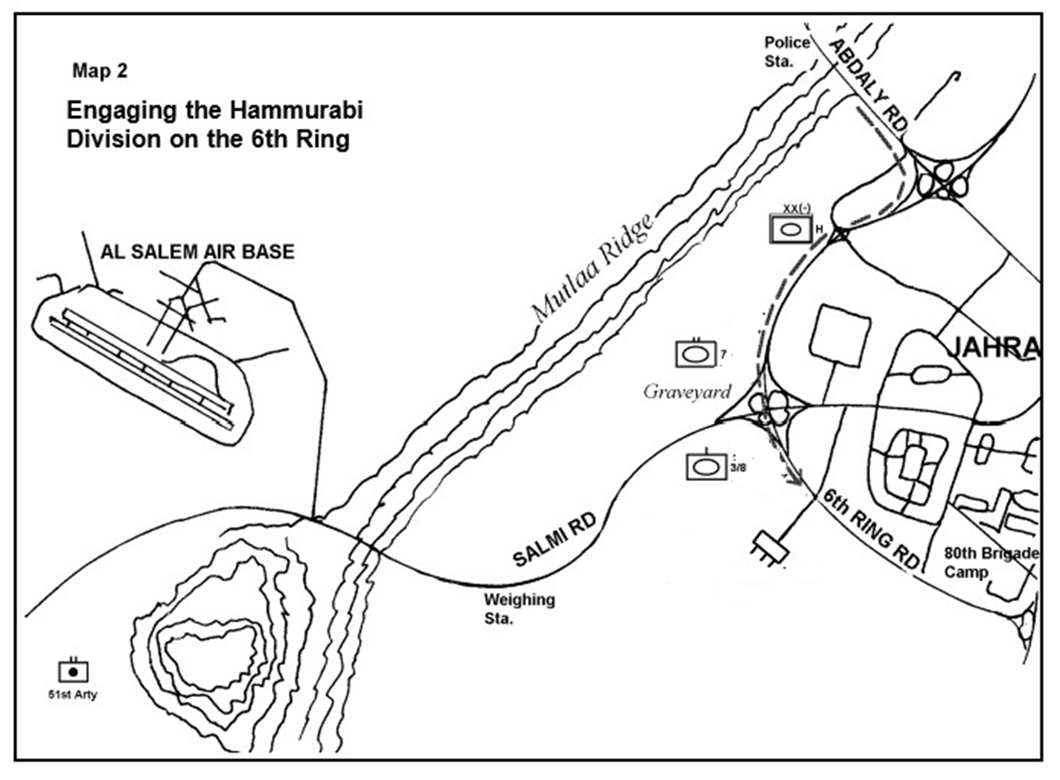

**MAP 4**

**1st Artillery Engagement**

Appendix 14

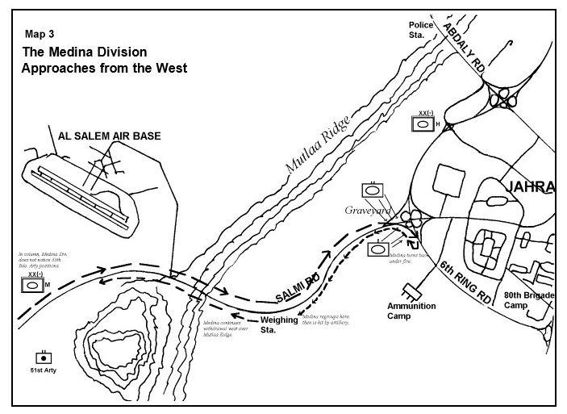

**MAP 5**

**2nd Artillery Engagement**

Appendix 15



**MAP 6**

**Artillery Engaged by BMPs**

Appendix 16

**BATTLE OF THE BRIDGES – PHASE 1: 1ST HAMMURABI ARMORED DIV – STAND 10**

At about 0500 on 2 Aug, having moved east along the Al Salmi Road to the vicinity of the Al Ghanim Oasis, 35 Bde took arrived in the area. The 25 Chieftain tanks of the 7th Bn plus their infantry and ITVs took up hull down positions in a line near the graveyard north of the road. Col Salem oriented his small force facing the Mutla Ridge

At about 0645, a Reconnaissance vehicle moved forward to the vicinity of the police station on the Mutla Ridge to investigate activity on

the Al Abdaly Road. They identified elements of the 'Hammurabi' Mech Div coming down the ridge attacking both east and west of Al Jahra.

The 'Hammurabi Mech Div reached Al Jahra in the early morning. They were apparently not expecting opposition as they were deployed

in road column and were neither reconnoitering nor securing their flanks. This careless behaviour and a consistent failure to use

communications were to be a defining feature of Iraqi units in the battle.

The Kuwaiti 7th Bn was the first to engage the Iraqis, sometime after 0645. The Chieftains, firing at a range of 1000 to 1500m, were very

effective; the Kuwaitis hit numerous vehicles and caused the column to halt. The Iraqi response was slow and ineffectual. Iraqi units

continued to arrive at the scene apparently unaware of the situation, allowing the Kuwaitis to engage infantry still in trucks and even to

destroy a Self-Propelled Gun that was still on its transport trailer.

However, due to confusion at higher echelons, Lt Col Al Wazzan received an order to cease firing and return to garrison. After several

minutes, he decided that the order was inappropriate and resumed engaging the Iraqis.

While the 7th Bn engaged the Iraqis from the north side of the Al Salmi Road, the 10 tanks of the 3rd Coy of the 8th Bn started to arrive.

Initially, the 3rd Coy commander, Capt Ali Abdulkareem had received an order to move his company across the 6th Ring Road and

attempt to free the 80th Brigade, trapped in garrison by the Iraqis. The 6th Ring is a 6-lane highway with concrete barriers separating the

north and south lanes and not easily crossed. The Iraqis controlled the two northern bridges and there was a long detour to reach the

next bridges to the south. Capt Ali moved forward in his tank, covered by his company, to conduct a personal reconnaissance. He

quickly realised that any attempt to cross the road, especially the central barrier would result in a massacre of his unit and so fell back.

Having done so he advised that it was not possible to continue his mission and the 8th Bn was subsequently directed to tie in with the 7th

Bn and stop Iraqi movement along the 6th Ring.

When Capt Ali closed on the southern flank of the 7th Bn, Lt Col Al Wazzan at first did not recognize them. He thought the Iraqis were

attempting to turn his flank from the south and directed a TOW platoon to move to cover his flank. Fortunately at the last minute he

recognised the Chieftains and didn’t open fire.

Capt Ali positioned his coy south of the Al Salmi Road to cover the two bridges over 6th Ring. Almost immediately after taking up positions a car came screeching up behind Capt Ali's tank. He was happy to see the gunner from his normal crew leap out of the driver’s

seat. The gunner was the battalion’s best shot, and had been at home on leave when the news of the Iraqi attack had come in. No

sooner than the gunner had taken his seat, he spotted and killed an Iraqi command/observation vehicle that was mostly obscured by a

bridge (the burn marks are still visible underneath this bridge.) The Iraqis were now trapped on the road. The rest of the company,

following Capt Ali's example, now began engaging the Iraqis. At first, all tanks fired at the same target, Capt Ali quickly directed his crews

to distribute their fires across the entire front. The enemy did not respond aggressively, abandoning their vehicles and hiding along the

road. Then an Iraqi platoon of three T-72's wormed its way through Al Jahra and tried to launch a flank attack on the 8th Bn. The Kuwaiti

tanks easily spotted them and destroyed all three.

While Capt Ali's company engaged the Iraqis on the road, a flight of 30 Hip helicopters flew across his front toward Al Jahra. Although Capt Ali wanted to engage them he was not able to elevate his gun high enough. He was not concerned until he saw a Hind at the trail of the formation. He recognized the threat but could not bring his gun to bear. The Hind turned and hovered as if it was preparing to engage. Again, Capt Ali's luck was with him. The Hind hovered for a few minutes, and then turned to follow the rest of the formation.

Iraqis continued to come down the 6th Ring Road, apparently unaware of the situation. A convoy of cargo trucks loaded with soldiers

passed in front of 8th Bn. The Kuwaitis engaged the trucks and several hundred troops dismounted. However, instead of deploying to

fight, most of the soldiers merely sat down on the side of the road to await the outcome of the day's events. Some Iraqi infantry moved

into the ammunition camp on Capt Ali's right flank. His flank tanks received small arms and RPG fire, but took no losses. Ali also

destroyed a 2S1 still mounted on a transport, indicating the Iraqis were still unaware and unable to react to the 35th Bde's fires.

Events slowed down along the 6th Ring Road. The Kuwaiti Artillery continued to engage the Iraqi soldiers sheltering among the wrecks

and behind the embankment along 6th Ring Road. Some Iraqi soldiers attempted to surrender, but the Kuwaitis turned them back

because they did not have enough soldiers to secure prisoners. The Kuwaitis took advantage of the lull in the fight to send vehicles back

to the brigade camp to replenish ammunition. As the morning wore on the lack of water began to tell, on both sides and so during lulls in

the battle soldiers from both sides queued up next to each other to buy water from a local roadside water vendor.

Appendix 17

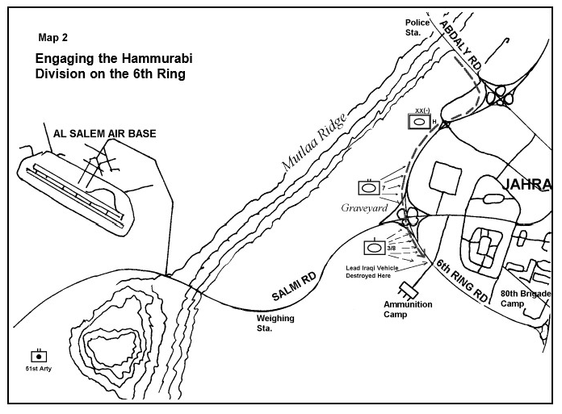

**MAP 7**

**Engaging the Hammurabi Div on 6th Ring Road**

Appendix 18

**BATTLE OF THE BRIDGES – PHASE 2: 2ND AL-MEDINAH AL-MUNAWERA ARMD DIV – STAND 11**

At about 1100 hrs, 35th Bde received information and identified an armored force, flying green flags, coming from the west towards

Al Jahra. Thinking that these were a Gulf Cooperation Council force moving up to reinforce them Capt Gassan walked over to question the lead vehicles. As he approached he realized that this was an Iraqi force because it was equipped with T-72s and BMPs, but he was too committed to turn around so decided to bluff it out. He asked the crew of the lead vehicle their identity and location of their commander. The crew answered, Gassan turned around, walked back, and passed the information to the brigade. The Iraqis continued to drive east along the Al Salmi Road between the 7th and 8th Bns. When the lead vehicles turned south on the 6th Ring, Kuwaitis fired into them. The 7th Bn turned to engage along their right flank and rear while the 8th Bn engaged a company-sized force to their front on 6th Ring Road.

These Iraqis were the lead brigade of the Medina Div. This division attacked from the west along the Al Salmi Road. Like the Hammurabi,

they were still in column on the road and had no idea of the resistance by the 35th Bde. Information found after the war indicated there

was no direct contact between the Hammurabi and the Al Madinah Divisions. In fact, the Al Madinah drove past the artillery firing positions and reserve tanks of the 35th Bde who were south of the Al Salmi Road in the vicinity of the Al Salem Airfield.

The fires of the 7th and 8th Bs caused heavy casualties and attrition in the lead brigade. The Kuwaitis captured six prisoners. The

brigade operations officer, Lt Col Suleiman Al Huwail, questioned them and they identified themselves as members of the Al Madinah Division.

The Iraqis withdrew towards the west along the Al Salmi Road, temporarily halting to regroup at a truck-weighing station located about 3km from the 7th and 8th Bns’ positions. The Kuwaitis quickly brought effective artillery fires on this point, causing additional casualties and confusion among the Iraqis. While the 51st Battalion was engaging the Al Madinah Division, a Kuwaiti A-4 Skyhawk attacked the Iraqi

columns just to the north along the Al Salmi Road with a total of five MK-82 500 pound bombs. The Al Madinah regrouped and attacked again, this time with two brigades deployed. However, having been given enough warning from the artillery position the 8th Bn shifted so that it refused its left flank, and could keep the Hammurabi Div to its front and also cover the back of the 7th Bn. The Al Madinah T-72s stormed down the road towards Al Jahra unaware of exactly what was happening and as it entered the frontal arcs of the 7th Bn all the defenders opened fire wreaking havoc. The Al Madinah Div was once again driven off to the west of Ali Al Salem where it started to regroup and prepare for a deliberate attack.

Appendix 19



**MAP 8**

**The Madinah Div Approaches from the West**

Appendix 20

**BATTLE OF THE BRIDGES – PHASE 3: WITHDRAWAL – STAND 12**

As the Al Madinah Div commenced its second attack, the Kuwaiti unit commanders informed Col Salem they were running short of

ammunition, in particular tank main gun rounds. Most tanks were down to two or three rounds of main gun ammunition. Col Salem

requested reinforcements and support from headquarters, but there was no additional support available. To prevent the brigade from

being encircled between the Hammurabi and now-deployed Al Madinah Divisions, Col Salem directed a withdrawal to new positions south of the Al Salmi Road. The 8th Bn covered the 7th Bn's initial move.

While his company covered the movement of the 7th Bn, Capt Ali stood on his turret to gain some relief from the heat. For no apparent

reason, his driver moved the tank about ten or twenty meters. The driver had never moved the tank without specific directives before. As

soon as the tank moved, an Iraqi main gun round hit the position they just vacated. After the 7th Bn set off, the 8th Battalion began to

move and again, Capt Ali was misidentified as Iraqi and almost engaged.

The Brigade continued moving south to a subsequent position to escape the closing Iraqi pincers. While repositioning, they received a

directive from higher headquarters to move toward the 15th Bde camp to replenish and continue to defend. However, higher

headquarters did not have an accurate picture of the battlefield and communication was tenuous at best. Joint headquarters informed Col

Salem to take whatever action he considered necessary. He decided to withdraw to position his back against the Saudi border and

secure his flanks and rear against envelopment during the night. Thus, the brigade continued to move south and set on the Saudi border,

arriving at about 1630. The brigade remained in position through the night. Lt Col Ahmad Al Wazzan, along with a recon element, moved

into Saudi Arabia and made contact with the border police and informed them who they were and the brigade situation. At the same time Capt Nasser Al-Duwailah realizing that the Brigade was almost out of ammunition and spare parts led a small group in trucks back to 35 Bde, where, under the noses of the Iraqis, they were able to sneak in and help themselves to the required ammunition and spares and return back to the Bde position. With the situation inside Kuwait becoming untenable the Brigade entered Saudi Arabia the following morning. The wisdom of this move was shown when shortly after the last units withdrew into Saudi Arabia, an Iraqi airstrike hit the recently vacated positions.

The Saudis assisted the Brigade in reorganizing and resupplying. While some units, such as the 7th Bn, were relatively well supplied with

water during the fight, others were suffering badly from a lack of water and all suffered from fatigue.

The Chieftain had proved it was able to do exactly what it was designed to do, hold larger forces of Soviet armor at bay and 35 Bde had held up the lead elements of two divisions for nearly ten hours.  As well as the one breakdown the brigade had only lost two tanks in the battle.

Appendix 21

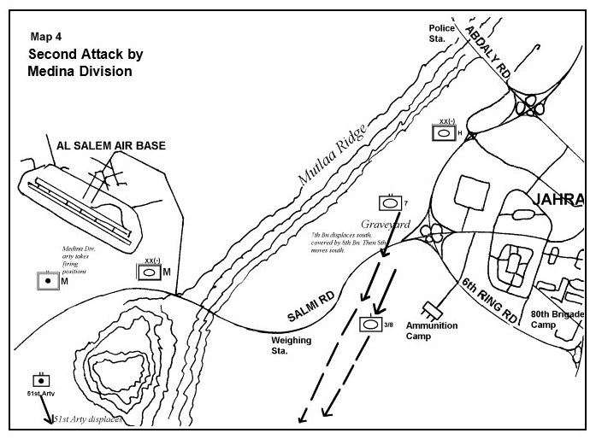

**MAP 9**

**35 Bde Withdrawal**